

Kaleidoscope Multi-Academy Trust

Strategic Plan 2021 - 2024



Contents

**Introduction2**

**Our vision, mission and values3**

**Kaleidoscope 5 C’s5**

**Leadership & Governance5**

**Delegated Roles6**

**Accountability8**

**Leadership Structure10**

**Model for School Improvement11**

**Strategic and Political Context14**

**Three Year Objectives17**

**One Year Objectives18**

**Longer Term Plan39**

**Kaleidoscope Services41**

**INTRODUCTION**

I am delighted to introduce the forth Kaleidoscope Multi-Academy Trust Strategic Plan covering the period 2021-2024. This plan sets out our 3 year strategic objectives, including our priorities for the coming year.

During the Coronavirus pandemic, schools have worked hard to support children’s education and wellbeing. Pupil’s education and how we manage our schools has been disrupted, with many elements of our role being adapted to meet the exceptional circumstances we found ourselves in. A large focus of this plan will include the next steps out of the pandemic and particularly a focus on how we address the gaps in pupils learning and manage the additional needs associated with wellbeing and safeguarding.

The Kaleidoscope Trust Board is determined to see a high performing and successful Multi-Academy Trust that delivers the very best educational experience for the pupils attending our schools. Our schools play a key role in the community supporting our families and offering our children opportunities to grow and thrive, academically, socially and emotionally. We want our children to be confident and resilient. An additional aim is to develop expertise across all aspects of primary education. We want to develop expert teaching and high quality leadership. This plan sets out how we will guide, support and improve our academies. Our schools work closely with each other but also with other schools/MATs, Teaching School, The Diocese of Bath and Wells and external professional agencies.

We have built a strong, collaborative and effective team over the last few years and now want to enhance this and drive improvement to further develop our schools and MAT.

I look forward to working with all of our staff and schools to deliver this plan to ensure the very best possible outcomes for all.

Simon Marriott

Chief Executive Officer

**VISION AND VALUES**

**VISION**

Kaleidoscope’s Visionis to create a Multi Academy Trust of exceptional and distinctive schools which deliver outstanding education and learning, who share best practice to raise standards and build aspiration for the children and members of its community, maintaining the positive diversity and choice for parents.

This vision will be achieved through the Trusts commitment, to the following Values:

**VALUES**

**Distinctiveness:**

We value and celebrate each school’s individuality and diversity whilst growing and learning together.

**Trust:**

We value the opportunity to work openly together in achieving our individual and common goals and aspirations.

**Integrity:**

We value honesty and professionalism when facing and overcoming challenges.

**Fairness:**

We value a community that has equality at its core; both in contributions and outcomes for all.

**Friendship:**

We value the mutual support and challenges of colleagues within a close community of schools.

**Commitment:**

We value the close collaborative relationship within our community for the benefit of all in support of group and individual needs.

**Strategic Aims**

To achieve our vision and meet our values we aim to:

* Maintain a knowledge of each other’s schools and learn from the distinctive characteristics and individuality of each school.
* Maintain and promote the Christian distinctiveness of the Church schools within Kaleidoscope.
* Provide a collaborative responsibility for ensuring:
* All schools are enabled to deliver the best possible outcomes for learners
* Sharing of best practice, assets and resources
* Continuous improvement for all schools
* Widening of curriculum and enrichment opportunities for all pupils
* To value each other’s contributions, make improvements which are broadly aligned with each school’s SDP and current governmental guidance and be accountable to each other and the communities we serve.
* Share, monitor and measure our educational and wellbeing goals for all children in schools within Kaleidoscope
* Create structures which achieve better use of resources through efficiencies in the provision and procurement of goods and service
* Explore and access additional sources of funding to support our aims
* Embed high aspirations and tackle low achievement and performance
* Develop our staff and provide additional career opportunities through Kaleidoscope
* Ensure that Kaleidoscope is outward looking and continues to work with all partners e.g.RSC, LA, other Trusts, the Diocese of Bath and Wells
* Become a leading light in the collaborative development of educational delivery and share our successes with others

**KALEIDOSCOPE MULTI-ACADEMY TRUST 5 C’s**

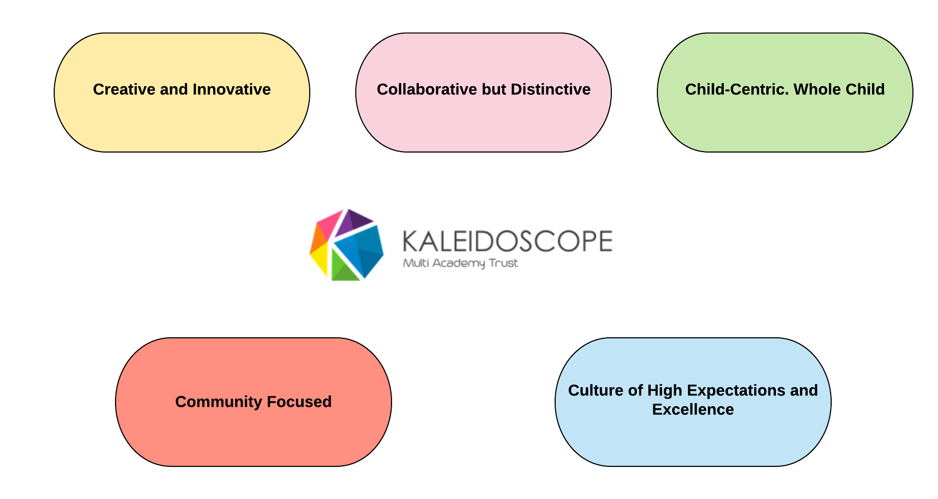

**LEADERSHIP AND GOVERNANCE**

As a Charitable Trust our Board ensures that the MAT complies with charity and company law requirements. The Board of Kaleidoscope has two core functions and that is to set the strategic direction of the organisation and ensure the financial probity of the Trust.

As a Multi Academy Trust, the Board of Kaleidoscope is responsible for all of the academies in the Trust. We do this by delegating functions to the Local Governing Body of each academy through a Scheme of Delegation.

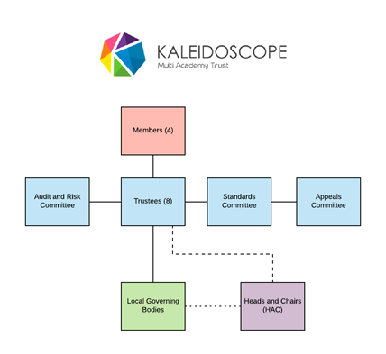

BEAT Member

**DELEGATED ROLES**

Kaleidoscope believes that the best results will be achieved when each individual academy’s LGB receives the level of responsibility and autonomy that is appropriate to their specific circumstances.

Where a school is not yet Good or Outstanding, there will be closer supervision of the school by Kaleidoscope through its officers and consultants. Those that are Good or Outstanding will receive light touch supervision and support so that the LGB will operate with maximum autonomy as detailed within the Scheme of Delegation. The Trust Board must have clear oversight and are accountable for the schools within the MAT.

For governing bodies to carry out their role effectively, governors must be:

* Prepared and equipped to take their responsibilities seriously
* Acknowledged by the lead professional in the schools and accountable to the Trust Board.
* Supported by the appropriate authorities in that task
* Willing and able to monitor and review their own performance

We would expect the core business of each LGB to be:

* LGB’s will approve the appointment of their Chairs, ensure that parents are elected to each LGB and will follow the structure and organisation as outlined within the KMAT Terms of Reference for Local Governing Bodies

Responsibilities will include:

* Building an understanding of how the school is led and managed

Monitoring whether the school is:

* Working within agreed KMAT policies
* Ensure local policies are in place, up to date and followed
* Is meeting the agreed targets
* Monitor that the school website complies with statutory and KMAT requirements, is clear, informative and promotes the school
* Monitors and reports that KMAT safeguarding procedures and training are in place
* Monitors and reports that staff and pupil wellbeing is a high priority
* Monitors and reports that the KMAT Health and Safety procedures and training are in place and followed
* Monitor that the school building is safe and well managed
* Monitor that the school has a broad and balanced curriculum and meets national and local requirements
* Monitoring that its finances and resources are within the budget set and agreed by the Trust Board
* Engaging with stakeholders
* In the case of Church Schools – demonstrating Christian distinctiveness and working with the agreed policies and principles of the Church of England and Diocese of Bath and Wells
* Form a panel to review complaints and exclusions
* Support the recruitment process
* Providing a representative to advise the CEO as part of the Headteacher/Executive Headteacher appraisal process
* Monitors that the school has suitable and sufficient staffing
* Reporting to the Board through the Governor representative attending HAC

***Full details are included within the Scheme of Delegation and Local Governing Body Terms of Reference.***

**ACCOUNTABILITY**

The Board of Trustees delegates responsibility for delivery of the vision and strategy to the CEO. The MAT Trustees Board holds the CEO to account for the performance of the Trust, including the performance of the academies within the Trust. The CEO in turn holds other MAT Centralised staff and Headteachers to account by line managing them.

The Scheme of Delegation also includes delegation to the CEO and Academy Headteachers as well as to the committees of the Board of Trustees. The Board cannot delegate its responsibility or accountability, but delegates some of the detailed scrutiny, oversight and decision-making.

As the CEO is accountable to the Board for the performance of the Trust as a whole, the CEO will report to the Board on the performance of the Trust including on the performance of the Trust’s schools, although this may be supplemented by monitoring reports from the LGBs.

The Trust Board determines on a case by case basis whether to delegate some day to day decision making, actions and monitoring concerning the performance of each academy to the Local Governing Body. (LGB).

Factors which may influence the decision to delegate include:

* School performance
* A recent Ofsted report
* Financial and administrative performance
* Leadership and governance capacity and capability
* Due diligence
* RAG Rating

Regardless of the schools’ performance, the Board of Trustees retains overall control, not the individual school; for this reason this model is referred to here as ‘Earned Autonomy’.

This model of earned autonomy requires more than one scheme of delegation. It should also be noted that the phrase ’earned autonomy’ is used to show that some Local Governing Bodies have decision making powers and some may be advisory (known as Local Academy Councils).

A Local Governing Body with decision making powers still reports to the Trust Board and its powers and decision making functions can be amended or revoked.

The Trust Board will review the performance of the CEO. The CEO is responsible for leading the Performance Management of the Headteacher.

**For those academies with local level delegation:**

The Local Governing Body (LGB) is responsible to the Trust Board. It is tasked with monitoring whether the school is working within the agreed policies, whether standards are being met, and if the money is being well spent. The LGB will use its detailed knowledge and engagement with stakeholders to ensure that their school is being well run and will report to the Trust Board. (See above for more detail).

**For those academies with restricted delegation:**

The Local Academy Council’s role is to understand how the school is led and managed, acting as the eyes and ears of the school and its community and have a role in influencing decision-making. They will report to the Trust Board.

**LEADERSHIP STRUCTURE**



**MODEL FOR SCHOOL IMPROVEMENT**

As set out in our vision statement, the core purpose of the Kaleidoscope Multi Academy Trust is to deliver an exceptional education for all learners in our Trust community. We will use this principle in developing an effective model for school improvement, which will ensure impact on the achievement and life chances of every child in the Trust.

In order to achieve this we have established the following Quality Assurance Procedures.

**RAG RATING/SEF REVIEW**

Each school will review its performance using the Kaleidoscope RAG Rating/SEF criteria. This is a live document which will be updated throughout the year. The judgements will be reviewed by school leaders, Governors, CEO and then reported to the Trust Board.

The focus areas include.

* SIAMS grade (if appropriate)
* Pupil attainment
* Pupil Progress
* Leadership and Management
* Quality of Education
* EYFS
* Behaviour and Attitudes
* Wellbeing and Personal Development
* Safeguarding
* Governance
* Finance
* HR/Staffing
* Health and Safety
* Exclusions
* Attendance
* School’s Overall Impact

If the school is showing a range of red indicators across key areas then the following process is applied:

1) Meeting with the CEO to discuss issues and review actions, and support – in line with the School Improvement Pathway.

2) If rapid improvement is not evidenced a full review is undertaken by the CEO and other professional/s.

3) If the outcome of the review causes concern (leadership capacity cannot enable rapid improvement) then the Trust Board meet to determine whether the school maintains Earned Autonomy.

**Shared data and Assessment Systems**

Kaleidoscope has common systems for recording assessments, targets and attendance. FFT Aspire and FFT Pupil Tracking are the core MAT wide systems for this. There is a Kaleidoscope Assessment Timetable which specifies set assessment points, common assessment formats and the specific year groups assessed. Reports are used to monitor in school progress/attainment and compare progress/attainment across Kaleidoscope as benchmark against national data. Judgements which are aligned to the RAG rating. The Trust Standards Committee meets at least three times per year to monitor/analyse data and the CEO reports findings, strengths, areas to develop and actions to the Trust Board. The termly CEO visits analyse these areas in detail.

**KALEIDOSCOPE SCHOOL IMPROVEMENT MODEL**

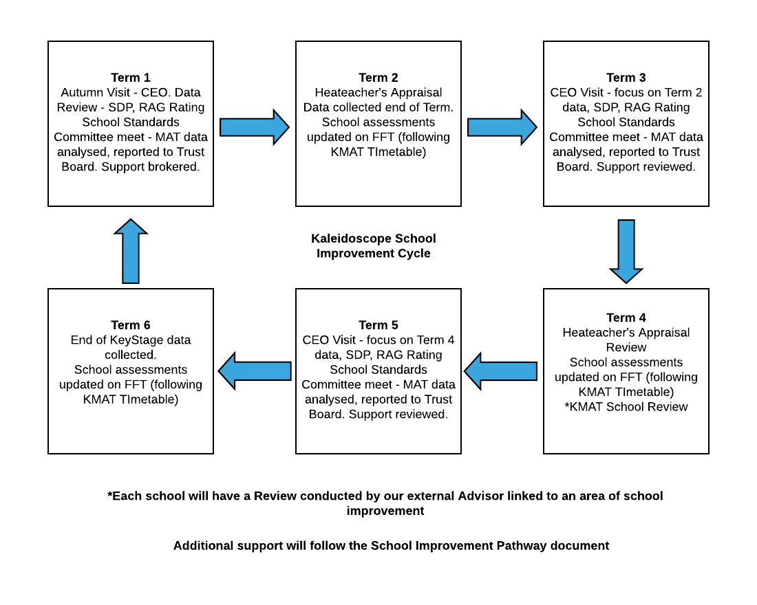

**STRATEGIC AND POLITICAL CONTEXT**

The Academies Act 2010 started the political journey that allowed more schools to become academies. The Education Act of 2011 then increased the powers of the Secretary of State for Education to intervene in poorly performing schools and require these to become Academies. It also created the presumption that all new schools will be academies or free schools.

The introduction of the role of Regional Schools Commissioner in September 2014 followed by the National Schools Commissioner in March 2016 has built an additional level of monitoring and scrutiny at a more local level for all academies and multi academy trusts.

**GEOGRAPHY AND COMMUNITIES WE SERVE**

Kaleidoscope MAT originally formed in Weston-super-Mare, when two smaller groups of schools that had been collaborating closely, joined together as Academies in September 2017. Initially Ashcombe, Becket, Christ Church C of E, Hutton C of E, St Martin’s C of E and Worle Village Primary Schools formed Kaleidoscope in September 2017. In February 2019, Crockerne C of E Primary School joined us.

Our schools are proud of the communities they serve, wanting to maintain their local identity within those communities whilst also benefiting from even closer collaboration as part of Kaleidoscope MAT. Four of our schools are Church Schools. We have close links with the Diocese of Bath and Wells and celebrate/promote the Christian distinctiveness of these schools.

There are pockets of severe deprivation in parts of central Weston, and in parts of Worle. The communities in Weston are heavily reliant on tourism for employment, although there are significant numbers that commute into Bristol every day.

**STRATEGIC PLANNING 2021-2024**

**Strategic Objectives**

As a Multi Academy Trust we have clear strategic aims which are founded on our mission and values. This plan sets out objectives to ensure that as a Trust, the public, parents and all stakeholders have confidence in our approach. We aim to deliver in:

**Strategic Leadership and Governance:**

To ensure that the Kaleidoscope Board of Trustees acts on behalf of its moral and legal owners in the best interests of the Trust, governing lawfully in accordance with its Articles of Association and having governance arrangements that demonstrate legitimate and visionary leadership, clarity of governing and managerial relationships, effective oversight, adequate support structures for sustainability and to achieve the greatest possible economies. Roles and responsibilities are detailed within the Scheme of Delegation and within the Terms of Reference for each specific level of governance.

**School Improvement - Teaching and Learning:**

To ensure that our academies provide the very best teaching in order to promote and provide high quality learning for our children and young people and that there is support in place for teachers to achieve this and make a difference for our pupils.

**Pupil and Staff Wellbeing:**

To ensure our curriculum, wider curricular support, and specific support including safeguarding, social, emotional and SEND enable our children to be confident and resilient in their learning, social interactions and be ready for their next stage of education.

To ensure that our staff are well supported and developed professionally, we monitor workload and review systems and practice to remove unnecessary workload burdens. KMAT staff have access to a 24 hour helpline and counselling service.

**Continued Professional Development:**

To implement a CPD programme for our academies to ensure that our staff have the right skills to further raise standards deliver good teaching and learning and disseminate good practice to ensure the rapid improvement

**Quality Assurance:**

To ensure that there is a rigorous and robust programme of Quality Assurance that helps to support teachers, build expertise and capacity and raise standards in our academies to deliver positive outcomes for pupils.

**Integrated Support & Shared Services:**

To ensure that the Trust has business arrangements that are efficient and effective and enables it to deliver on its commitments to grow and prosper and deliver value for money across all of the Trust. Delivering best practice, minimisation of risk and for management of resources to be concentrated to the front line of our academies.

**OBJECTIVES 2021-2024**

On our journey to deliver against the 3 year strategic objectives in 2021 -2024 we will focus on the following:

1. Enhancing leadership and governance at all levels

2. School improvement, standards and effectiveness

3. Enhance pupil and staff wellbeing

4. Develop 3 year financial forecasting and make savings to ensure long term financial health and balanced budgets.

5. Develop the curriculum so that it meets Ofsted expectations

6. Plan staff development to improve practice and opportunities across the MAT

A key focus for Kaleidoscope is there is a drive for raising standards across the curriculum to enable our pupils to achieve well. Additional support and procedures will be put in place to support a school which is at risk as detailed within the RAG Rating.

**Developing & Growing Kaleidoscope Central Operations**:

A key strategy is to promote and develop the Trust and the services we offer to our schools. This means that our Academies can focus on improving Teaching & Learning and delivering educational excellence. We will work across a range of partnerships including neighbouring Multi Academy Trusts, and other partners to share good practice and jointly procure services to bring about better value for money and economies of scale.

**HEADLINE SHORT TERM PLAN 2021-2022**

|  |  |  |  |  |  |
| --- | --- | --- | --- | --- | --- |
| **Leadership and Governance** | **Standards** | **Wellbeing** | **Finance** | **Curriculum** | **CPD/Pedagogy** |
| Enhance KMAT Leadership and Governance at all levels.  Introduce and develop the Executive Leadership Team.  Expand and develop KMAT Networks so that they drive KMAT development and improvement. | To raise achievement across all Kaleidoscope schools. To develop high quality pedagogy, systems and practice.  New Early Years Framework consistently planned and implemented across KMAT.  Catch-Up /Recovery Funding and National Tutoring Programme is well planned and used to support pupils to make rapid progress.  To rapidly raise the standards, progress and attainment at Becket Primary School | Pupil and staff Mental health and wellbeing is a key Kaleidoscope priority in our curriculum, pastoral care, policies, procedures, training and support. This includes supporting the longer term impact of COVID-19 on pupils and staff mental health. | Further develop systems for 3 year budget forecasting.  Review staffing structure and conduct restructuring to make necessary savings.  Seek savings for MAT supplies and services  Expansion | All MAT schools have embedded a broad, progressive curriculum which has a clear focus on knowledge and skills. MAT schools curriculums have a clear intent, implementation and impact. Schools provide a comprehensive Home/Blended Learning offer and can revert to this to support isolating pupils or groups. | Develop a comprehensive programme for staff development (at each career stage including ECT)) and create more opportunities for staff career progression within Kaleidoscope.  Develop a KMAT approach to pedagogy, teaching and learning  Create a KMAT list of experts (Resource Base) accessible for school support and improvement. |

**DETAILED SHORT TERM PLAN 2021-2022**

|  |  |  |  |  |  |  |
| --- | --- | --- | --- | --- | --- | --- |
| **Objective 1**: Enhance KMAT Leadership and Governance at all levels. | | | **Success Criteria**   * New ELT has MAT wide impact raising standards and improving practice * Networks have MAT wide impact in raising standards and improving practice * More staff have opportunities to be involved with MAT wide improvement * Leadership knowledge and skills developed due to greater available opportunities. * Full complement of Members, Trustees and Local Governors * Governance is well trained and fully knowledgeable of MAT issues (appropriate to each level). * Governance at all levels has the wide range of skills and knowledge needed for the roles. * Clear systems (electronic) and processes are in place to enable Trustees (at MAT level) and Governors at school level to monitor key areas and hold leaders to account | | | |
| **Actions** | **Person Responsible** | **Resources** | **Budget** | **Timescale** | **CPD** | **Monitoring** |
| Create Executive Leadership Team (ELT), where all KMAT EHT, HT, lead a key area, develop practice and monitor existing practice across the MAT | SM | N/A | N/A | Sept 21 | Internal.  Lead area specific | Reported at each Trust Board Meeting  ELT members will produce reports for the Trust Board. |
| Develop Networks so they cover more areas and take a stronger lead in MAT wide development. | SM | Release time | n/a | Feb 22 | Leadership development  National College subject training | Reported at each Trust Board Meeting  Minutes sent to CEO and stored on shared Headteacher drive. |
| Review the Scheme of Delegation and Terms of Reference for Governance at all levels. Ensure there are clear roles and lines of accountability. | SM, TC |  |  | September 2021 |  | Trust Board monitor each level of Governance working consistently and within roles and responsibilities. |
| Embed the training programme for Members and Trustees. (to include Diocese training for Foundation Members/Trustees) | SM - DD, TC | NGA Tools  ESGOS.  Diocesan programme.  Internal training - data, safeguarding, finance.  Accountants. | n/a | July 2022 | Programme of CPD. | Standing item on each meeting. |
| Further develop systems to enable clear oversight by Trustees and LGB (at school level) of key areas including safeguarding, health and safety, site and premises, training, school improvement, wellbeing - staff and pupils. | SM, JW | KMAT Compliance Tracker, SCR Online, FFT, shared documents/pro-forma  Google Drive | n/a | July 2022 | Training to use systems. | Reported at each Trust Board Meeting |
| Develop and refine tools to internally audit Governance at all levels. | SM, TC |  | n/a | Dec 2021 | n/a | Report progress to Trust Board and Members. |
| Commission an independent review of kaleidoscope governance. | SM, TC | Diocese | tbc | February 2022 | n/a | Outcomes reported to the Trust Board and Members. Local Governance outcomes highlighted at LGB Meetings and HAC |
| Embed a training programme for Local Governing Boards. (to include Diocese training for Foundation Governors | JB | Governor Handbook.  Governor training programme.  NGA Tools  ESGOS.  Diocesan programme.  Internal training - data, safeguarding, finance.  Accountants. | n/a | July 2022 | Programme of CPD. | Standing item on each meeting. Chairs feedback at Heads and Chairs Meetings. |
| Recruit suitable Governors and Trustees. | Members and TC | Follow best practice.  Skills audit. Interviews. | n/a | July 2022 | n/a | Annual review of Member and Trustee effectiveness. |

|  |  |  |  |  |  |  |
| --- | --- | --- | --- | --- | --- | --- |
| **Objective 2**: To raise achievement across all Kaleidoscope schools. To develop high quality pedagogy, systems and practice.  New Early Years Framework consistently planned and implemented across KMAT.  Catch-Up /Recovery Funding and National Tutoring Programme is well planned and used to support pupils to make rapid progress. | | | **Success Criteria**   * Attainment at least in line with FFT 50 (school targets) * Progress scores within progress bands. * All schools attainment and progress graded as green within RAG rating. * Catch Up/Recovery Premium have impacted positively on learning – gaps narrowed. * All schools teaching and learning graded as green within RAG rating. * Focused cpd offer in place - impact measured. * Evidence demonstrates curriculum networks drive change. * All schools using the FFT tracking system * Positive impact of Catch-Up funding evidenced. | | | |
| **Actions** | **Person/Group Responsible** | **Resources** | **Budget** | **Timescale** | **CPD** | **Monitoring** |
| Plan the spending of the Catch Up/Recovery Premium so that each school identifies key areas to focus additional support/programmes and resources | Headteachers | Various – depending on school choice | Catch Up/Recovery Premium funding | July 2022 | Cpd on use of funding – National College, DFE Guidelines The Key documents. | Schools monitor internally.  Schools produce reports accounting for spending and impact.  CEO monitors at school level and reports to Trust Board. |
| Each MAT School undertakes a focused review with an independent advisor - focus = curriculum | SM | N/A | Advisor costs | April 2022 | n/a | Each review produces a report.  Schools create actions from areas identified within report.  Reported back to the Trust Board. |
| To strengthen Subject and Curriculum Networks and empower them to drive improvement across Kaleidoscope schools | SM and Network Leaders (Headteachers) | N/A | Staffing release costs | July 2022 | Programme of Subject Leader Network meetings detailed in MAT Termly Overview. | Monitored at Headteacher Meetings.  Reported to the Trust Board.  Impact reviewed - how school improvement driven by networks. |
| Develop a kaleidoscope approach to pedagogy which is research led, based upon best practice and links to national expectations. | Executive Leadership Team - Cpd/Pedagogy  SM, JC, LF  Teaching and Learning Network - CP | N/A | N/A | July 2022 | Cpd programme devised by the ELT  Cpd delivered in MAT INSET and Staff Meetings  Key areas delivered at school level by Teaching and Learning Lead. | Reported to Trust Board.  KMAT pedagogy a focused in observations and wider monitoring. |
| Finish and then embed a common set of objectives/KPIs set for English, Maths and Science to ensure consistent approach to teacher assessment across KMAT. | Subject Teams | FFT Training | N/A | July 2022 | Training on new system. | Subject Team Leaders report to CEO.  CEO reports to Trust Board. |
| EYFS Network works together and with external advisors to create a consistent KMAT to the new EYFS Framework. | GV | Advisors – SM, SR | Staff release | Term 1 2021, review throughout year. | Training on new framework and KMAT approach. | GV updates HTs.  School monitoring that agreed approach in place.  Report to Trust Board. |
| Schools use Tapestry to record Rec assessment data. Key reports sent to CEO | Headteachers, EYFS Leaders  Assessment Leaders | Tapestry | N/A | July 2022 | Training on the new system. | Monitored at Headteachers Meetings.  Reports used to inform Governors about standards.  Reported to Standards Committee Trust Board.  System used to effectively monitor school achievement across all year groups and inform CEO visits, RAG Ratings.  Headline information and key issues reported to the full Trust Board. |
| Review standardised tests and continue consistent approach to delivery, monitoring and analysis as part of the annual assessment cycle. | Headteachers and Assessment Network | Standardised or published tests. | Test costs. | July 2022 | Training on application and using data from new tests. | Monitored at Headteachers Meetings and Assessment Network.  Reported to the Trust Board. |
| Further develop assessment and moderation tools and systems for all subjects. | Subject Networks | N/A | Staffing release costs. | July 2022 | Staff training on assessment and moderation. | Monitored at Headteachers Meetings and Assessment Network.  Reported to the Trust Board. |
| Further develop fluency in Mathematics. Improve outcomes at ARE and HS | Maths Subject Team (KJ) | N/A | Staffing release costs. | July 2021 | Staff training on Maths fluency. | School level observations and monitoring.  Report to the Trust Board and MAT Improvement Committee. |
| Improve outcomes for writing at all levels, recap Writing Revolution Improve outcomes at ARE and HS.  Improve spellings and Grammar outcomes at ARE and HS. | English Subject Team  (SE) | Resources to be agreed |  | July 2021 | Staff meetings Writing Revolution  Additional training for English Leaders. | Observation and monitoring at school level.  Report impact to the Trust Board. |
| Improve the outcomes of vulnerable pupils including pupil Premium, SEND through sharing and implementing best practice and national guidelines. Ensure additional funding is well spent and has impact. A MAT working party will review and develop best practice so our vulnerable pupils succeed. | SEND, Pupil Premium Networks. | N/A | N/A | July 2022 | cpd raising outcomes for vulnerable groups. | School level monitoring.  Reviewed CEO visits.  Reported to Trust Board and monitored at Standards Committee.  Focus for monitoring |
| Improve outcomes for HS pupils so that they are at least in line with the NA | ELT CPD and Pedagogy group – SM, JC, LF | N/A | N/A | July 2022 | Teach to the top approach  MAT Pedagogical style/tools | Reported to Trust Board and monitored at Standards Committee.  Focus for monitoring |

|  |  |  |  |  |  |  |
| --- | --- | --- | --- | --- | --- | --- |
| **Objective 3**: Pupil and staff Mental health and wellbeing is a key Kaleidoscope priority in our curriculum, pastoral care, policies, procedures, training and support. This includes supporting the longer term impact of COVID-19 on pupils and staff mental health. | | | **Success Criteria**   * More effective behaviour management systems and structures reduce incidents of negative behaviour FT and permanent exclusions. * Surveys show staff more positive with improved mental health perception. * Surveys show that pupils are more positive about their wellbeing. * Training is in place for MAT staff. * Staff are aware of the support available to support their wellbeing and mental health. * PHSE is high profile and embedded across the curriculum. * Opportunities to develop pupil leadership are evident in all MAT schools. * MAT schools have taken part in the Home Office Trusted Relationships Fund programme | | | |
| **Actions** | **Person Responsible** | **Resources** | **Budget** | **Timescale** | **CPD** | **Monitoring** |
| Develop Wellbeing ELT focus and actions across KMAT | SM and YB | N/A | N/A | July 2022 | Linked to need | YB and SM monitor across the MAT.  Report to Trist Board. |
| Review structures and capacity for behaviour management. Investigate successful models. Adapt school and MAT approach. | Headteachers | N/A | N/A | July 2022 | Investigate successful schools/MATs in challenging circumstances.  Investigate their structures and systems. | Monitor the number of behaviour incidents and exclusions - report to Trust Board. |
| Conduct an audit on staff mental health. Analyse and make changes to address concerns/issues. | YB/Mental Health Champions | The Key and other good examples for audit. | Release | January 2022 | Wellbeing staff meetings | Audit results and actions monitored at school and Trust Board level. |
| Develop an annual programme for behaviour/social emotional and wellbeing training. e.g. THRIVE, Pivotal, De-escalation training | Headteachers | Review models from other MATs | tbc | July 2021 | Training in systems and strategies | Heads to report to LGBs. CEO to report to Trust Board |
| Conduct a pupil wellbeing survey. Analyse and plan changes to address concerns/issues. | YB/Mental Health Champions | Review examples of best practice |  | March 2022 | Presentation of survey results and actions to address issues. | Report outcomes and progress/impact of actions to Trust Board. Monitor at LGB level. |
| Raise the profile of PHSE. Review how often and the content of what is taught. Ensure it is regularly taught with comprehensive coverage (includes preventative factors)and embedded throughout the curriculum | PHSE Leaders. | Review best practice e.g. Jigsaw. | Resource costs | July 2022 | School based staff meetings and cpd. | Schools review and monitor PHSE coverage at leadership and LGB level.  Report to CEO - report to Trust Board. |
| Develop opportunities for pupil leadership e.g. Pupil voice, MAT Council, Sport leaders, | School SLTs    CEO – MAT Council | N/A | N/A | July 2022 |  | Monitoring by Leadership teams and LGBs.  Headline report to Trust Board. |
| MAT Schools access mental health training including Trusted Adult and DFE Funded training. Schools Mental Health Leads work together to develop best practice. | YB/SM | Support from NH | N/A | July 2022 | CPD delivered at MAT and Network level. | Impact monitored at school level - leaders and LGB  Updates to Trust Board. |
| Train 2x KMAT staff to deliver Team Teach restraint approach across KMAT | SM | 2x MAT staff | Costs for training, and release time for delivery split across KMAT Schools | Jan 2022 | Cpd delivered to key staff – Team Teach | Schools to monitor impact of training, report to CEO. |
| Develop a COVID Outbreak management Plan which meets statutory requirements and clearly supports schools in managing increased cases. | SM | N/A | N/A | Sept 21 | SM to go through with Headteachers | Approve Procedures at Trust Board. |

|  |  |  |  |  |  |  |
| --- | --- | --- | --- | --- | --- | --- |
| **Objective 4**: Further develop systems for 3 year budget forecasting.  Review staffing structure and conduct restructuring to make necessary savings.  Seek savings for MAT supplies and services.  Expansion | | | **Success Criteria**   * audits completed successfully * All schools submit balanced budgets. * Schools have reviewed staffing and will make necessary changes to structures in line with declining rolls * MAT office costs held within 5.5% top-slice * MAT meets all statutory requirements as detailed within the Academies Handbook. * MAT has been successful in bids | | | |
| **Actions** | **Person Responsible** | **Resources** | **Budget** | **Timescale** | **CPD** | **Monitoring** |
|  |  |  |  |  |  |  |
| Work with effected MAT schools to support the reduction in pupil numbers by reviewing and reducing staffing, resourcing and other costs. | SM/CFO | Finance Office / One West, Bishop Fleming | Time / audit fees | Jan - July 2022 |  | Trust Board - Finance report  Audit and Risk Committee |
| Ensure risks are fully managed and reported to Trustees. Reference the schools Risk Register | CFO | Risk Register | Costs linked to risk mitigation | July 2022 |  | Audit and Risk Committee -  Finance report |
| Develop the MAT central office team, including school based finance staff. | SM, JW, KN | Staff | Staff budget | July 2022 | Staff training as required | Trust Board - Finance report |
| Complete / resubmit CIF bids for schools who meet the criteria.  Submit appeal, emergency bid and develop emergency funding option for Ashcombe’s building. | Ashcombe HT and Govs, Tom Bishop / CEO, CFO | N/A | Academy contribution to CIF bid - £250,000 | Nov 2021 for UCS and CIF Submission | N/A | Trust Board – CEO Report  Audit and Risk Committee |
| Survey schools and submit CIF Bids for improvements e.g. heating | Headteachers, CEO, CFO, Tom Bishop | N/A | School contributions | Nov 2021 for CIF submission | N/A | Trust Board - Finance report  Audit and Risk Committee |
| Review contracts and services - seek best value. | CFO – Procurement Network | Finance office / time | Time | July 2022 |  | Trust Board - Finance report |
| Pursue expansion – demonstrate that MAT systems and resources capable of supporting and developing additional schools. | CEO/CFO/ Expansion Network, TC | N/A | N/A | Ongoing | N/A | Updates to Trust Board and Members. |

|  |  |  |  |  |  |  |
| --- | --- | --- | --- | --- | --- | --- |
| **Objective 5**: All MAT schools have embedded a broad, progressive curriculum which has a clear focus on knowledge and skills. MAT schools curriculums have a clear intent, implementation and impact. Each school’s curriculum embodies the KMAT curriculum principles. Schools provide a comprehensive Home/Blended Learning offer and can revert to this to support isolating pupils or groups. | | | **Success Criteria**   * All schools have a clearly defined, progressive curriculum, that is broad and all subjects high profile. * Curriculums have clear Intent, Implementation and Impact based upon agreed KMAT principals. * A planned range of assessments are used to inform planning, teaching and learning and assess against age related expectations. * Subject Leaders confidently lead and manage their subjects – leading cpd, monitoring standards, experiences, coverage and outcomes. * All schools have a clear Home Learning system in place. | | | |
| **Actions** | **Person Responsible** | **Resources** | **Budget** | **Timescale** | **CPD** | **Monitoring** |
| Develop the subject leadership expertise of Foundation Subject Leaders. | Headteachers | MAT Networks,  Local Networks | n/a | July 2021 | National College cpd. | Headteachers and LGBs monitor leadership training.  MAT Review focus on curriculum and Leadership.  CEO to report to Trust Board. |
| Develop a set of Kaleidoscope curriculum principals which all schools follow and embed in their curriculum Intent and implementation. | Headteachers | n/a | n/a | March 2021 | Headteacher group review curriculums design across schools and ensure that MAT framework, philosophy incorporated, ensuring Christian distinctiveness. | CEO to report to Trust Board. |
| Schools review curriculums and redesign where necessary to ensure that there is a clear programme that is progressive, is clear about what knowledge is taught and what skills pupils will develop. | Headteachers, curriculum leaders. | n/a | n/a | July 2021  review progress Dec 2020, March 2021 |  | Schools monitor curriculum internally with LGB.  CEO monitors curriculum overview and reports to Trust Board.  MAT Review - focus on curriculum |
| A range of assessment tools are created that support teacher assessment of all subjects. It shows what children have learnt and what skills they have developed. | Headteacher, curriculum leaders | View examples of best practice. | n/a | July 2021 | Internal cpd led by Subject Teams and SLT. | Schools and Subject Leaders monitor that assessments completed consistently.  Report to LGB. CEO to report to Trust Board. |
| Develop staff subject expertise from focused cpd and by joining linking to subject associations. | Subject Teams | Subject memberships and any training costs tbc | n/a |  | cpd undertaken by subject Leaders cascaded to school | Schools monitor and report to CEO. |
| Schools develop a Home/Blended Learning offer which meets all pupil needs. This takes account of accessibility issues including IT access at home. | Headteachers |  |  | October 2020 |  | Schools to monitor and report to CEO - Home Learning Plans.  HTs to report to LGB.  CEO to report to Trust Board. |

|  |  |  |  |  |  |  |
| --- | --- | --- | --- | --- | --- | --- |
| **Objective 6**: **Develop a comprehensive programme for staff development (at each career stage including ECT)) and create more opportunities for staff career progression within Kaleidoscope.**  **Develop a KMAT approach to pedagogy, teaching and learning**  **Develop internal school to school support.** | | | **Success Criteria**   * There is a clear understanding of expectations at each pay grade. * Opportunities developed for staff development – they are included in school improvement * A comprehensive cpd offer is published * ECTs receive a high quality induction package and are well supported by mentors. * Subject Networks are focused and develop best practice and shared direction for MAT schools. * The ELT cpd and Pedagogy Group leads and presents best practice in pedagogy (based upon research) | | | |
| **Actions** | **Person Responsible** | **Resources** | **Budget** | **Timescale** | **CPD** | **Monitoring** |
| Embed new MAT wide appraisal, UPS and Career Expectations document to ensure consistent approach across all MAT schools. | SM and School leaders. |  | N/A | July 2022 | N/A | Headteacher updates to LGB and CEO to Trust Board |
| Review and create opportunities for staff development across the MAT. E.g. teachers supporting other schools/staff to raise standards, work in other schools in increase capacity, career development opportunities. Also the sharing of staff - mentoring, managing budgets, staff retention.  Create a new Staff Resource base | CEO | N/A | Release covered by receiving school | July 2022 | Depends on development need/focus. | Updates to Trust Board, also monitor impact on school lending support. |
| Develop a high quality development and support offer for Early Careers Teachers (ECTs) which includes cpd, mentor support, MAT ECT Network | RW, SM | 5 Counties Teaching Hub  Ambition Institute | Government funding | Sept 2021 | cpd for ECTs and Mentors provided by Ambition Institute | RW monitor quality and experience of ECTs  Report to trust Board. |
| Create a KMAT list of experts (Resource Base) accessible for school support and improvement. | SM/Standards Committee | Internal experts | Release time | November 21 |  | Monitoring by Standards Committee  Report to Trust Board. |

**LONGER TERM PLAN 2021-2023**

|  |  |  |
| --- | --- | --- |
| **Focus Areas** | **Year 2 2022-2023** | **Year 3 2023-2024** |
| **Leadership and Governance** | Embedded Executive Leadership Team –extended roles and responsibilities – directly impact on MAT improvement.  Any development areas from Governance review addressed – strong governance evidenced at all levels.  Full complement of LGB  All LGB have undertaken full training programme. | Full complement of LGB  All LGB have undertaken full training programme. |
| **Standards** | Becket school has closed the gap with national outcomes.  All schools are at least with National averages for attainment and progress.  Standards are raised across all curriculum subjects. | MAT schools are exceeding national averages for attainment and progress.  Internal data shows good attainment and progress across all year groups and schools are acting to address where it isn’t.  Standards for wider curriculum in line with Maths and English. |
| **Wellbeing** | Set up a Staff Wellbeing Committee at school level to feed ideas to SLT.  Kaleidoscope publicising wellbeing support to wider community. | Kaleidoscope schools have a reputation for exemplary policy and practice relating to wellbeing. |
| **Curriculum** | All Kaleidoscope schools have high quality curriculum and assessment procedures in place. | Kaleidoscope schools curriculums are exemplary and used as a model of best practice. |
| **Staff Development** | The cpd programme is comprehensive and meets schools and staff development needs. Good links are formed with the Teaching Hubs and other providers so that there is a clear path for particular courses and training.  School to school support operates quickly and effectively and impact can be demonstrated.  There are clearer options for staff to work between or support schools across the MAT. | Kaleidoscope staff moving more fluidly between schools to share expertise and fill staffing needs.  The MAT is retaining and developing highly skilled staff.  The MAT is in a position to support use expertise to support non-Kaleidoscope schools to generate income. |
| **Finance** | All finance systems are embedded and integrated.  The MAT has made financial savings and meets budget KPIs  Budgets balanced and steps taken to address impact of falling pupil numbers.  Where Bursars/Finance Managers leave/retire - central team take on key roles to enable cost savings at school level.  Further staffing review and restructuring if needed. | Finance system contracts are reviewed.  More centralised approach to enable savings.  All schools managing well within budgets.  Aspiration to manage payroll and pension processing in-house.  Further staffing review and restructuring if needed |

**OUR SERVICES**

Kaleidoscope MAT office provides a range of services, including outsourced services for academies within the MAT. These services are covered by a top-slice (currently 5.5% of the academy GAG).

The following services are provided (in conjunction with our external advisors):

**What Does the Top-slice Provide?**

|  |  |  |  |  |
| --- | --- | --- | --- | --- |
| **Systems** | **Professional Advice** | **Staffing Central Team** | **Central Services Costs** | **Other** |
| Budgeting  Finance  HR  Payroll  FFT Evaluation and Tracking  FFT Attendance  Safeguard  SCR Online  The Key for School Leaders  National College - cpd  Online banking | Legal Retainer  HR  Core External School improvement Advisor visits  Data Protection Officer  Governors – NGA, SGOSS | CEO  PFO  Senior Finance Officer  Finance Officer  Admin  Clerking, Company Secretary | Rent  Computers  Furniture  Printer and printing costs  Telephones | ICO Licenses  Central Team cpd  Training for school office teams |

*The Central Team also negotiate for the whole MAT for supplies and services, creating savings at school level.*